ACTRESS CV

Severija Janusauskaite
Agent contact:  Joint Stock Company „Akoriu agentura“  Pilies st. 7-2, 01123, Vilnius, Lithuania  Ph./fax: +370 5 2611771  Mobile: +370 677 77486  Email: andrius@actorsagency.lt  Location: East Europe (Lithuania, Vilnius)  Height: 170 cm (5'7") Build: slim Hair:brown Eyes: blue Role Playing Ages 20-30 Languages: Lithuanian, English, Russian Accents:british english,american english | 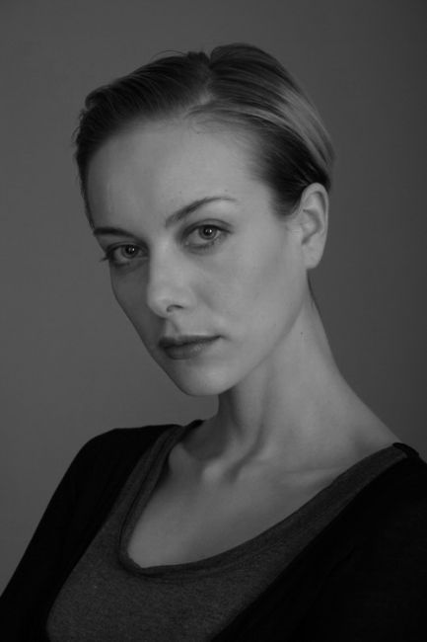

TV and Film
2008 Anarchy in Zirmunai Sandra Tremora (Lithuania), Katapult films (Hungary) Dir. By Saulius Drunga screenplay, which get New Talent Award at Cannes Film Festival in 2007
2008 Honeytrap TV series Vaida Dir. By Per – Olav Sorensen
2007 War and Peace Gipsy Girl Lux VideVide, RaiFiction (Italy) Dir. By Robert Dornhelm
2007 No Focus (Short ) Smoking Girl AXX film festival (Lithuania) Dir.By Ernestas Jankauskas
2004 The Flame (Short) The Woman Summer MEDIA Studio (Lithuania) Dir.By Are Nikkinon

Theatre

2008 Ferryman Beatrice Oskaras Korsunovas theatre Dir.By Paul Eugene Budraitis

2008 Patriots Liucija State Youth Theatre of Lithuania Dir.By Jonas Vaitkus (The Golden Cross of Scene nomination for the best woman‘s underpart)

2007 Ivona, Princess of Burgundia Malgozhata State Youth Theatre of Lithuania Dir.By Jonas Vaitkus

2006 The woman before Romi Arts Printing House Dir.By S.Uzdavinys, A.Jankevicius

Voice over:

2007 Ratatouille Colette (Lithuanian dub) Pixar

2007 The Simpsons Movie Bart (Lithuanian dub) 20th Century Fox

2007 Shrek The Third Rapunzel (Lithuanian dub) DreamWorks Animation

Training:
- 2001-2005 Music and Theatre Academy (Lithuania)
- 2004 Summer MEDIA Studio (Lithuania) Krzysztof Zanussi masterclass

Skills:
Painting, dancing, joga, swimming, fencing, professional make-up disign

Music Skills:
- Singing: Alto. Chorus and Solo Singing
- Instruments: Piano

